Computerized Rideshare Program

**User Manual**

Group B

**About**

This document provides an overview of how to work with and use the Computerized Rideshare Program (CRP). The CRP is limited in its use to the employees of the Southern North Dakota University (SNDU). The aim of the program is to cut down on costs for commuting employees and to alleviate overcrowding in the SNDU parking lots. In the following sections this document will provide information on how the CRP system works and how to go about using it. Images will be provided when necessary to better guide the user.

The CRP was created by:

|  |  |
| --- | --- |
|  | Subramanian Arumugam |
|  | Mohanakrishnakumar Karunakaran |
|  | Rajeev Reddy Vishaka |
|  | Saulius Milevicius |
|  | Steven Rago |

**Table of Contents**

1. **System 4**
   1. Registering **5**
   2. Logging in **6**
   3. Points **7**
   4. Member Types **7**
   5. Notifications **7**
   6. Opting out **8**
2. **Carpool 9**
   1. Allotment **9**
   2. Schedule **9**
   3. Passenger Capabilities **10**
   4. Driver capabilities **11**
   5. Editing your details **12**
   6. Opting out **13**
   7. Selecting a new carpool **14**
3. **FAQ 15**

**A.** **System**

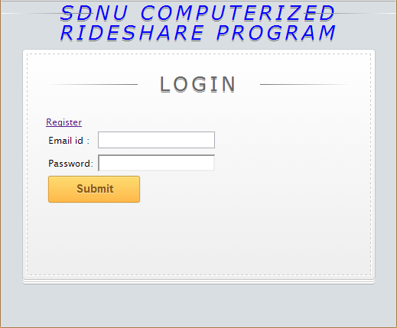

The CRP system runs as a web application on SNDU’s servers meaning that you can access it anywhere you have access to an internet connection. The system enables employees to quickly learn who is in their carpool, what duties they have that day and enables a fair share point system for the members of the system.

Before using any features of the system the SNDU employee must first either register, if this is the first time using the system, or log in. A user may register by clicking the Register button or entering their email and password if they already own an account.

**1. Registering**

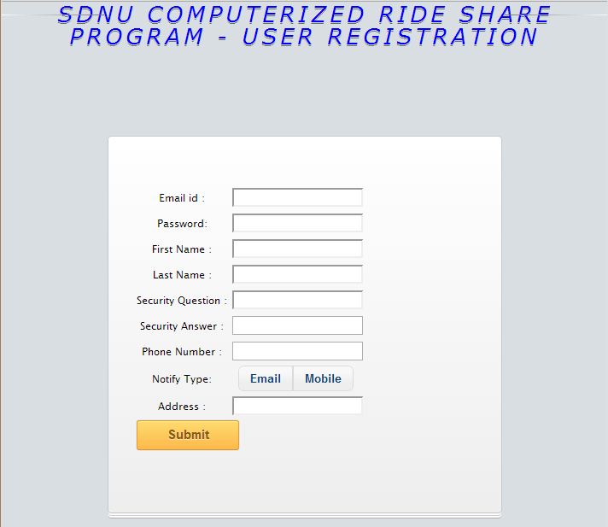

When using the system for the first time the user must first register. When registering you must provide the following details:

* An Email address
  + Your email address will be used when logging in as well as sending you email notifications
* Password
  + The password that you will use for logging in. It is recommended for you to use a strong password to prevent unwanted intrusions into your account.
* First and Last name
  + Other members of your carpool will be able to see your name.
* Security question and answer
  + Provide a security question and answer that the system can use in the event you forget your password.
* Phone number
  + Your phone number will be made available to other members of your carpool so they may be able to contact you. Optionally, it may be used to send notifications in the event you choose to be notified by mobile.
* Notification type
  + You may select whether to receive notification via email or mobile**[1]**.
* Address
  + Your address will be made available to other members of the carpool to know where to pick you up.

Once you have entered all of your details, clicking on the submit button will enter you into the system and assign you into an available carpool.**[2]**

**2. Logging in**

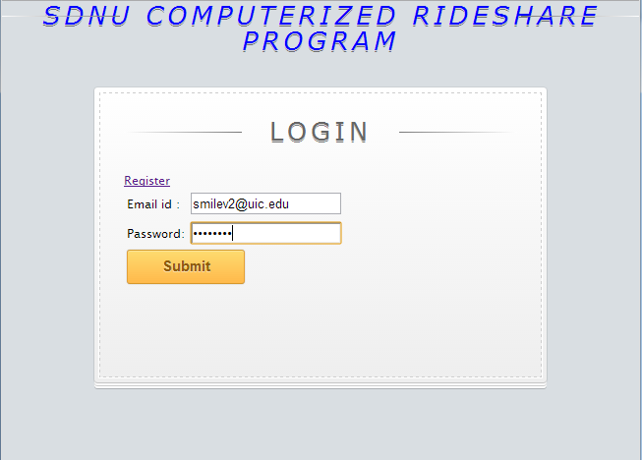

If you already own an account you may log back into the system by providing your account’s email and password. Upon clicking submit, if the credentials you enter are correct, you will be taken to your carpool’s information page.

**3. Points**

A new member of the system starts out with 10 points. Points are gained for driving a carpool to and from work and point deductions are given for various actions. Consult the following table for the actions that impact your points:

|  |  |
| --- | --- |
| **Reason** | **Amount** |
| Registering | +10 |
| Driving a carpool to and from work | +2 |
| Canceling a pickup | -2 |
| Canceling a drive | -3 |
| Opting out of carpool | -3 |
| Issuing an emergency | -2 |

**4. Member Types**

A member can be either a passenger or a driver of their carpool.

**Driver:** The driver is responsible for picking up any employees that are show in the carpool list and driving them to work. When driving from work not all members of the carpool need to be present, however, any employees left behind at work will be required to issue an emergency to be taken home.

**Passenger:** The passenger is a member of a carpool that is not driving that week. The passenger may cancel being picked up for a particular day by the carpool driver, however, the member canceling will be deducted points. The passenger may also issue an emergency should they end up staying later at work that the carpool’s driver.

**5. Notifications**

Notifications are sent out to the email that was provided during registration. Emails will come from crpcs442@gmail.com. Reasons for sending out notification are, but are not limited to:

* Member cancels pickup
* Member cancels driving
* Bi-Daily alerts of your carpool’s information
  + These are sent out Mon-Fri at 8am and 5pm

Optionally, you may select to be sent notifications via the mobile phone number you registered with.

**6. Opting out**

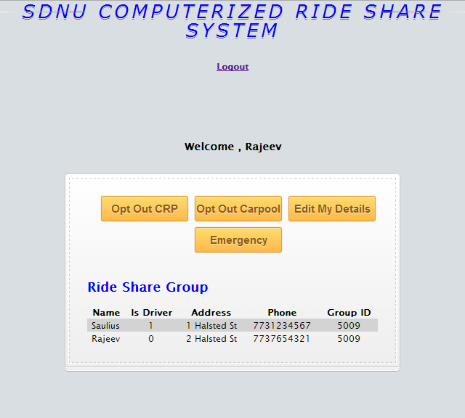

If you would like to completely leave the CRP system, press the ‘Opt Out CRP’ button. You will be removed from the system and be taken back to the main screen. You should only select this option if you are either leaving SNDU or are no longer interested in participating in a carpool. If you simply want to switch pools you may select the ‘Opt Out Carpool’ button, which is detailed in section B of this help manual.

**B. Carpool**

A carpool is defined as a group of one to four members that share a single member’s car to drive to and from work, thereby reducing the amount spent on gas as well as alleviating overcrowding at SNDU.

**1. Allotment**

Members are assigned into carpools as they join the system. A carpool is composed of 4 members. When a member joins the system they are either placed into any existing carpool with less than four members or the system allocates a new carpool and places the new member into that carpool.

The member that is first assigned into a new carpool becomes that carpool’s first driver, whereas any future employees will be passengers.

A member can, at any time assuming they have enough points, opt out of their carpool and join any existing carpools that have less than four members.

**2. Carpool Schedule**

The carpool system runs on a weekly schedule. An employee stays a driver for a week, after which the member that comes after the employee in the carpool group list becomes the driver the following week. The system sends out a notification to each member every morning and evening at 8am and 5pm detailing who is participating in the carpool.

**3. Passenger Capabilities**

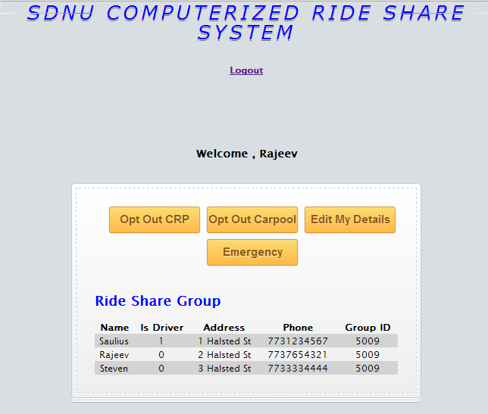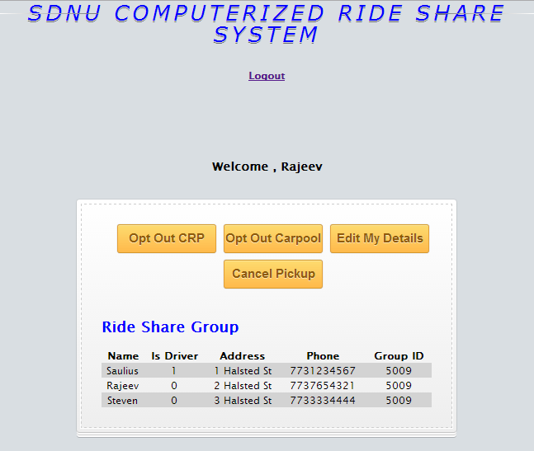

Most abilities described here and further detailed separately in sections A and B of this manual.

**Log out:** At any time you may log out of the system by pressing the Logout button located at the above the carpool details. Afterwards you will be taken to the login page.

**Opt Out CRP:** At any time you may opt to leave the system completely. Afterwards your account and information will be removed from the system.

**Opt Out Carpool:** Although the CRP automatically assigns you into a carpool upon registering into the system you may leave your current carpool at any time, as long as you have enough points**[3]**. Afterwards you will be presented with a page that lists all the available carpools that you may join**[4]**.

**Edit Details:** At any time you may edit certain details of your account**[5]**.

**Canceling Pickup:** You may cancel being picked up by the driver as long as you have enough points**3** and the driver has not yet indicated they have arrived at work.

**Issuing an Emergency:**If you find yourself staying late at work and missing your carpool, you may issue an emergency. This will place you into an available carpool as long as you have enough points**3**.

**4. Driver capabilities**

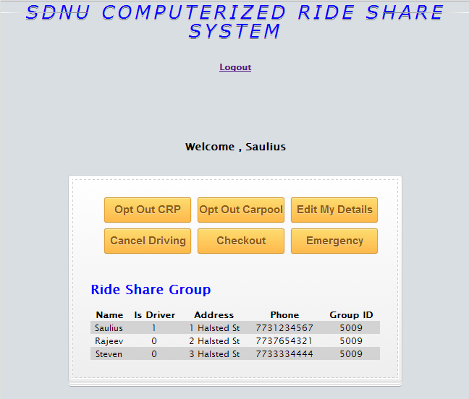 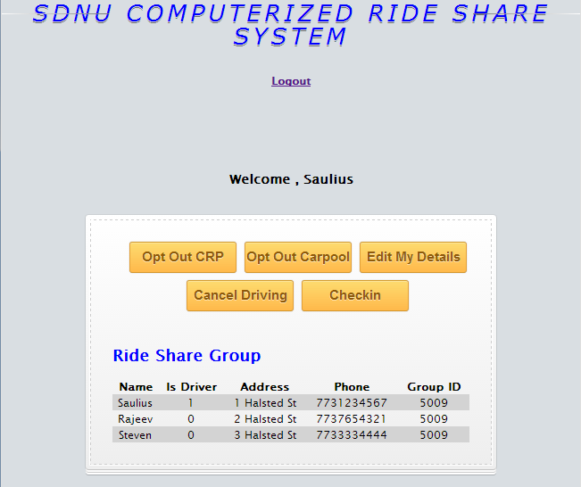

Most abilities described here and further detailed separately in sections A and B of this manual.

**Log out:** At any time you may log out of the system by pressing the Logout button located at the above the carpool details. Afterwards you will be taken to the login page.

**Opt Out CRP:** At any time you may opt to leave the system completely. Afterwards your account and information will be removed from the system.

**Opt Out Carpool:** Although the CRP automatically assigns you into a carpool upon registering into the system you may leave your current carpool at any time, as long as you have enough points**[6]**. Afterwards you will be presented with a page that lists all the available carpools that you may join**[7]**.

**Edit Details:** At any time you may edit certain details of your account**[8]**.

**Canceling Driving:** If you have enough points**6** you may cancel driving the carpool for a particular day. A member from your carpool will be made driver temporarily for that day and will earn any points you would have.

**Issuing an Emergency:** If you find yourself staying late at work and missing your carpool, you may issue an emergency. This will place you into an available carpool as long as you have enough points**6**.

**Check in/out Carpool:**As the driver, you areresponsible for alerting the system when you reach work and when you are leaving. The system will use your alerts to update your carpool’s information and enable and disable the actions that members are allowed to perform.

**5. Editing your details**

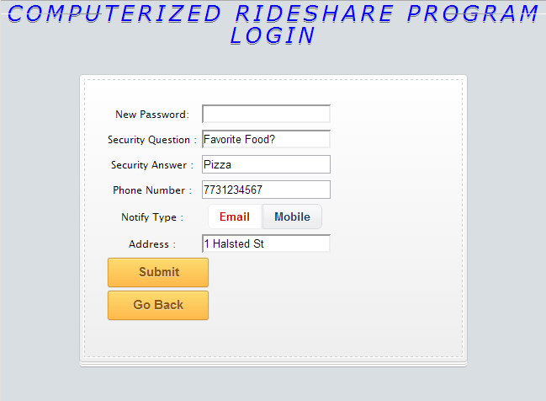

You may change certain details about your account such as the security questions and answer, a new password, a new phone number, a new address, or changing your notification type[9]. Any existing details will be loaded when you reach this page and any changes made will be saved upon submitting the form.

**6. Opting out**

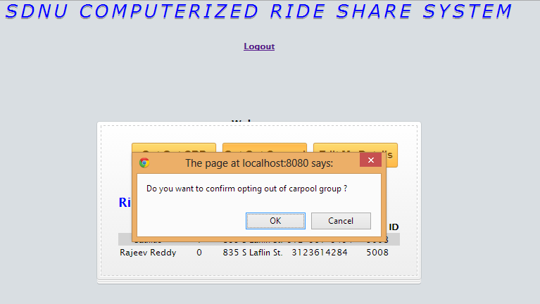

Upon selecting to opt out of your carpool you will be given a chance to confirm your selection. If you click Cancel your account will not be affected. Upon clicking Ok, you will be removed from your current carpool and be taken to a page to select an available carpool to join.

**7. Selecting a new carpool**

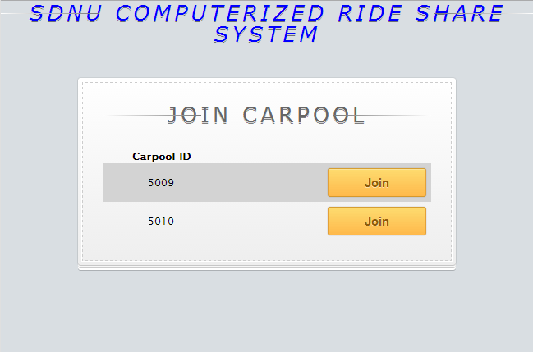

If you have left your carpool you will be taken to a screen similar to the one pictured above. Any carpool that contains less than four members will be displayed and you will have the option to join them. Joining a new carpool is as easy as selecting one from the list and clicking the Join button[10].

**C. FAQ**

The following are some Frequently Asked Questions (FAQ) about the CRP.

**I have just registered and can’t see an Emergency or Cancel Pickup/Driving button?**

Logging out and then back in will enable the buttons to appear. The system must finalize your account before you are able to see these.

**I only see the Emergency button and not the Cancel Pickup button (or vice versa)?**

You will always only see one of these. If the carpool is at work it is too late to be picked up, and you will only see an emergency button. If the carpool is not at work you will see the Cancel Pickup button.

**I am not receiving email alerts (or they are being sent to spam)?**

Make sure you add crpcs442@gmail.com to your contacts; this is the email alerts are sent out from.

**When I opt out of my carpool I only see my old carpool in the list?**

Unfortunately that means there are no other carpools available. You will have to wait until a new one is created or someone else leaves their carpool.

**When I join a new carpool after opting out of my old one I get an error?**

The system needs to finalize your changes so you should navigate back to the main page and log back in to allow the system to finalize and allow you to see your new carpool information.

1. Although you are able to select the mobile option, alerts through your mobile phone will not be available until version 2.
2. It is advised you log out after creating your account to finalize your entry into the system. The next time you log in you will be presented with your carpool’s information and your full account capabilities.
3. Consult section A.3 for further information about point deductions
4. Consult section B.7 for further information about joining new carpools
5. Consult section A.5 for further information about editing your account details
6. Consult section A.3 for further information about point deductions
7. Consult section B.7 for further information about joining new carpools
8. Consult section B.5 for further information about editing your account details
9. Currently only email notifications are sent out; mobile alerts will be implemented in version 2.
10. It is advised that after joining a new carpool you log out to finalize all the updates inside the system. You will be presented the details of your new carpool the next time you log in.